

Project Proposal

Kshetra - A Vector Field Plotter

JULY 2021

# 

# 

**Submitted by**

Aabhusan Aryal [076BCT001]

Mohit Agarwal [076BCT035]

Prabigya Acharya [076BCT043]

**Submitted to**

Department of Electronics and Computer Engineering

Pulchowk Campus

# Acknowledgment

We express our sincere gratitude to the entire Department of Electronics and Computer Engineering, Pulchowk Campus for providing us the opportunity to work on this amazing project. Special thanks to our lecturer Er. Daya Sagar Baral for helping us learn the concepts without which this project would have been impossible to build.

We would also like to thank our classmates Pramish and Nisan who helped us brainstorm the idea for the project.

Thanks goes to every other soul who has always been supportive to us in any possible manner.

**Table of Contents**

**Acknowledgment** **1**

**Introduction** **3**

**Objectives** **4**

**Existing System** **4**

**Proposed System** **4**

Description 4

System Block Diagram 6

**Methodology** **7**

**Project Scope** **7**

**Design Prototypes** **8**

**Project Schedule** **9**

# Introduction

Kshetra (क्षेत्र) is a simple two dimensional vector field plotter. A vector field is a very important topic in Physics and Maths. A vector field is essentially the assignment of a certain vector for each point in space. For instance, we can take an example of fluid flow. If we place an object over a flowing fluid, we can observe that the object moves in some direction, which may continuously change. We can conclude that a certain force is being applied to the object by the fluid when it is placed over the fluid. This force may not be equal at all points. For eg- The object may flow fast in some regions, or slow down in some other regions; it may turn right in some points, or left in some other points.

Hence we can describe this system with a vector field. The vector at each point in the field represents the force experienced by the object at that point. Some other examples of vector fields are the Gravitational Field and the Magnetic Field.

Plotting a vector field can help us visualise what the individual forces at each point look like, which in turn helps us develop a solid idea about fields in general, and the work done in moving an object through such fields.

# Objectives

The main objectives of building this project are:

1. To apply theoretical knowledge about Object Oriented Programming in a real life project.
2. To learn the features of C++.
3. To learn to implement graphics using SFML- a multimedia library.
4. To build reusable UI components.
5. To learn to collaborate and work in a group.
6. To get the hang of the best practices while coding a real life project and preparing ourselves for other major projects to come.
7. To fulfill the course’s requirement.

# Existing System

A handful of graphing tools like [Desmos](https://www.desmos.com/calculator/eijhparfmd), [Wolfram Alpha](https://www.wolframalpha.com/input/?i=plot+a+vector+field&f1=) and [GeoGebra](https://www.geogebra.org/m/QPE4PaDZ) already exist which can plot graphs including Vector Fields. The UI of our application is heavily inspired from GeoGebra’s UI.

# Proposed System

## Description

As mentioned earlier, Kshetra is a two dimensional vector field plotter. Our proposed system consists of a main menu, which has two options for a user to select. One option consists of some frequently encountered vector fields in our academic studies. The other option takes the user to a blank graph sheet, where the vector field is generated from the users’ input.

Kshetra not only plots a vector field in a graph, but also color codes it, as well as scales the length of arrows according to the magnitude of the vector at a particular point. The arrows will be scaled based on the general appearance of the graph, so that it doesn’t appear cluttered. This enables the user to study vector fields effectively and intuitively, while maintaining enough colours to avoid monotony.

SFML has been used as a multimedia library in our project. We have implemented all the graphical elements of this project using this library. All the UI components used in Kshetra have been built from scratch. It is important to note that all the features mentioned may not be available in our final release. Also, more features may also be added to our proposed system.

## System Block Diagram

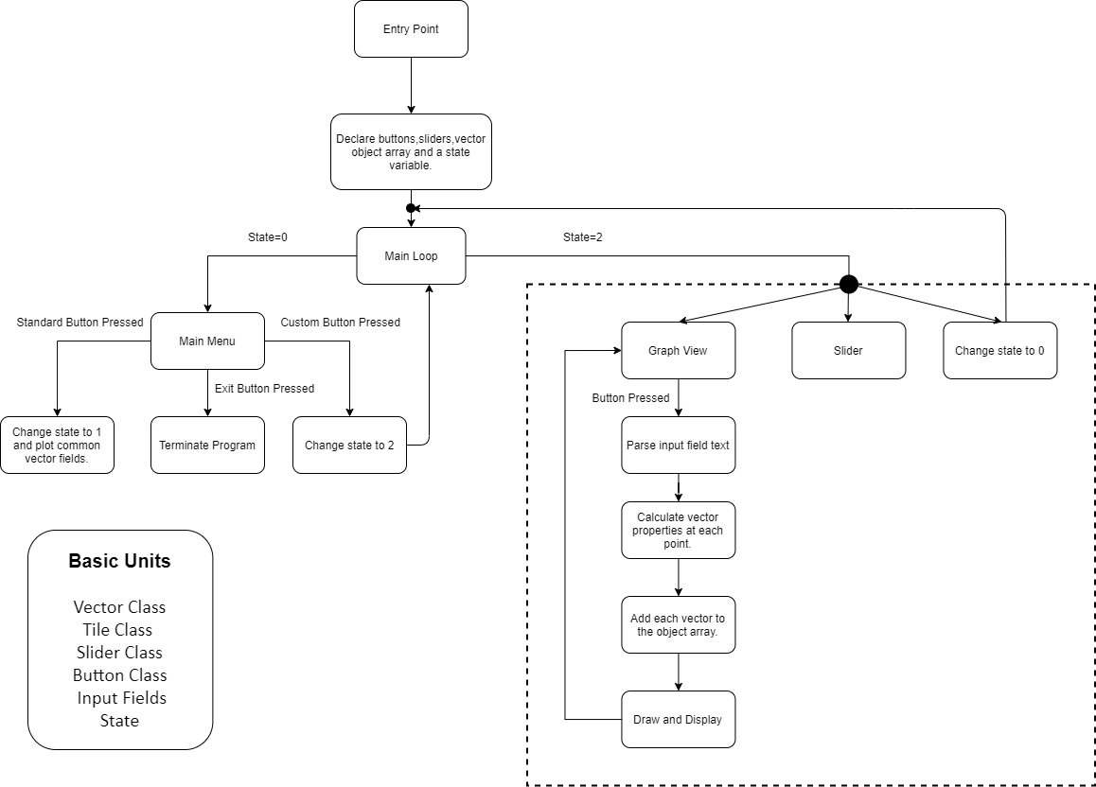

Fig: State Block Diagram of Kshetra

# 

# Methodology

We’ll be using C++ as our language of choice mostly because of its speed, versatility and most importantly because it’s our course requirement. We’ll use VS Code as our code editor, GCC 7.3.0 to compile our programs, and Windows Make as our build system.

We’ll be taking the Object Oriented approach to make our project much more manageable. Object Oriented approach also enables working in a team easier due to features such as encapsulation, abstraction etc.

We plan to incorporate the Simple and Fast Multimedia Library (SFML v2.5.1) to implement graphics mostly due to its simplicity and speed. We’ll be making all the UI components such as Buttons, Sliders, Text-Boxes ourselves from scratch. We will be referencing the documentation of the used libraries whenever necessary.

# Project Scope

A vector field plotter may seem simple, but [there’s more to it than meets the eye.](https://www.collinsdictionary.com/dictionary/english/theres-more-to-this-than-meets-the-eye) Some applications, to name a few, include use in the areas of Mathematics and Science. We have vector fields everywhere. So a reliable means of visualising it can go a long way in understanding many concepts in Maths or Physics.

In basic curriculums in schools or colleges, a student is often found confused when introduced to a new topic, especially in Physics. A tool that visualises such complex graphs can come in handy to both learners and teachers.

Given enough resources and time, Kshetra can be developed into a full blown application for graphing not only two dimensional fields, but also three dimensional.

# Design Prototypes

We have already designed a few UI components that we plan to use in our application like Buttons, Sliders and Grids in [Figma](http://figma.com/). Here are a few examples:

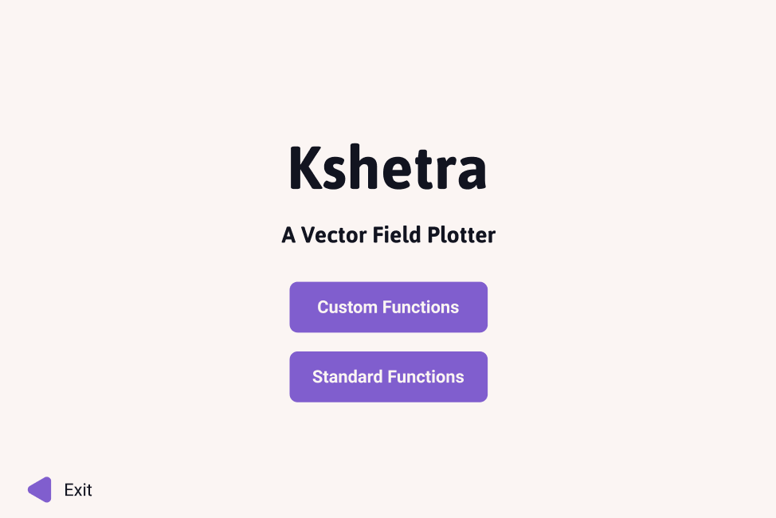

Fig: Main Menu

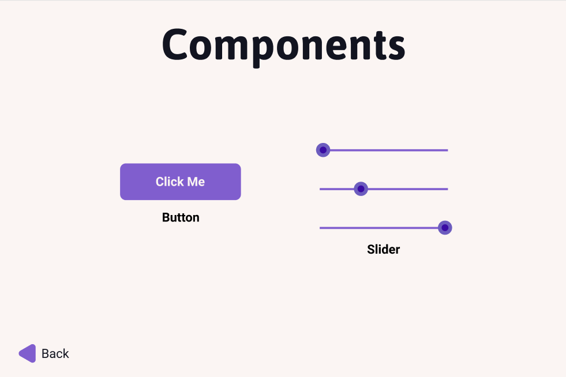

Fig: Button and Slider Components

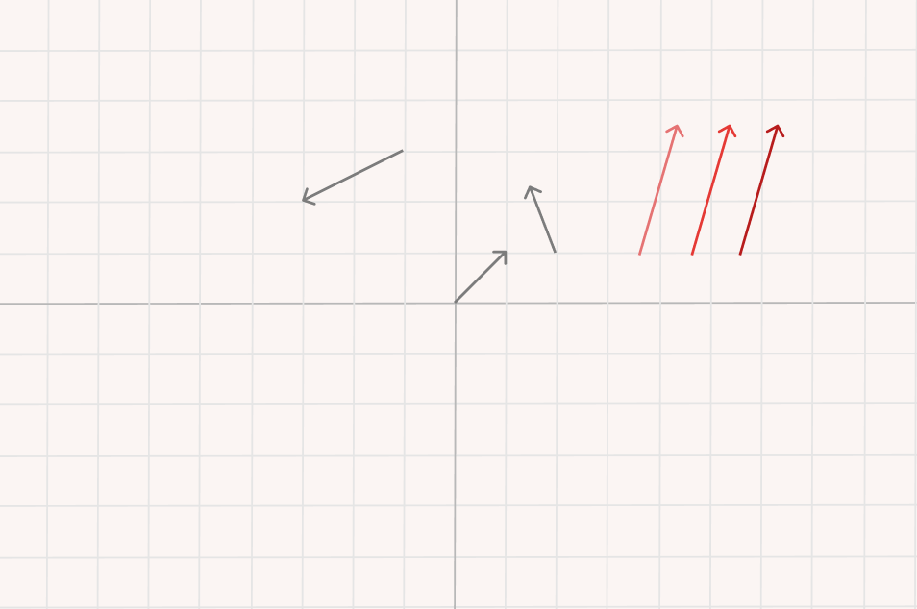

Fig: Grid and Some Test Vectors

# Project Schedule

1. Idea Brainstorming -> 1 day
2. Initial structure planning and environment setup -> 1 day
3. Learning the basics of SFML and best practises -> 1 day
4. Coding the different components -> 15-20 days
5. Bringing everything together -> 2-3 days
6. Testing -> 5 days

The project will be debugged and documented throughout the duration of developing the program.

Tentative final release: 1st week of August.